NEW COURSE FOR FALL 2023!

CPLT BC3204
Literary Worldmaking: Two Case Studies
Fall 2023
Wednesdays, 4-6 p.m.

Professor Rachel Eisendrath, Department of English
Professor Emily Sun, Program in Comparative Literature and Translation Studies

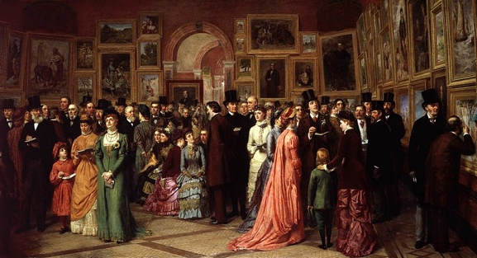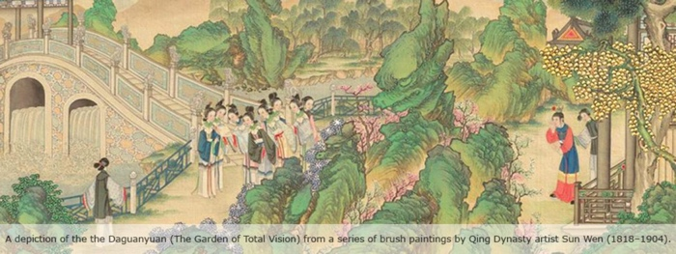

This seminar engages students in the immersive and intensive reading of two masterworks of modern prose fiction: Middlemarch, published by George Eliot (the pseudonym of Mary Ann Evans) in 1871-2 in England, and The Story of the Stone, or the Dream of the Red Chamber, composed by Cao Xueqin (and continued by Gao E) in the late 18th-century moment of Qing-dynasty China. While using devices and conventions from different narrative traditions, these novels operate in the mode of realism and do so at a monumental and panoramic scale, creating literary worlds that reflect the realia of historical lifeworlds. Beyond representing aspects of empirically recognizable worlds, these novels also incorporate philosophical reflection on their own means of representation, on their very status as fiction, on the power and limits of imaginative worldmaking. We will engage in our reading with such topics as sex, class, money, femininity, the uses of doubling, the work of dreaming, the writing of interiority, narrative and the experience of time, the pursuit of knowledge and the power of desire.
By studying these novels as cases of literary worldmaking, we will take the opportunity also to reflect critically in this class on the world that emerges–and the process of worldmaking that gets activated–in our very experience of studying these texts together. We will consider how cosmopolitanism, as a guiding ideal of the Enlightenment and post-Enlightenment university, may be renewed by literary study to help us inhabit a world of common humanity that is richer and more complex than is evident in particularist localisms or a satellite-view, techno-economic globalism.
Middlemarch we will read in its entirety. For the sake of time, we will read, in David Hawkes’ translation, the 80-chapter version of The Story of the Stone, or the Dream of the Red Chamber, attributed to Cao Xueqin, instead of the 120-chapter version, with the last 40 chapters attributed to Gao E. If you can and wish to read the text in Chinese, extra discussion sections can be scheduled with Professor Sun.
Capped at 16 students. Preference to comparative literature majors and English majors, but open to students in other majors as well. Sophomore or more advanced standing recommended.

