CPLS BC 3200 The Visual and Verbal Arts Fall 2020
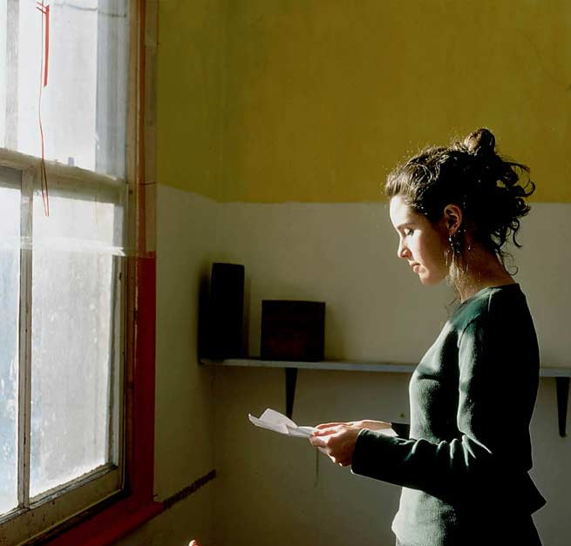
acts of looking … moments of reading
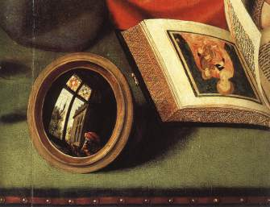
… scenes of writing …

CPLS BC 3200 The Visual and Verbal Arts

Instructor: Prof. E. Grimm
Milbank Hall 320 b, Barnard College
Office hours: M 10:00-12:00; and by appointment
e-mail: egrimm@barnard.edu

COURSE DESCRIPTION: What is this course about?

In two sentences:

This survey examines the interrelation of literature and the visual arts with an emphasis on the historical development from realism via modernism to contemporary literature. Major texts of the last two centuries provide examples of how painting, photography, and film interact with literary texts.

READINGS include novels, plays, poems, and essays (in English or in an English translation). Major writers include Henry James, Balzac, Proust, Cortazar and Rilke.

Books ordered for this course:

1 9780802150264 Nadja by Breton ; translated by Richard Howard. New York: Grove Press London :Evergreen Books, Ltd.,1960.

2 9780940322745 The unknown masterpiece and Gambara by Balzac; translated by Richard Howard ; introduction by Arthur C. Danto. New York: New York Review Books, 2001.

3 9780375751547 Swann's way by Proust; translated by C.K. Scott Moncrieff and Terence Kilmartin ; revised by D.J. Enright. New York: Modern Library, 2003.

REQUIREMENTS: Learning how to “read” modern texts and images

Required tasks and activities:

Three term papers (c. 6-7 pp.) (45%)
A final exam at the end of the semester (25%)
Participation in classroom discussion (15%)
Brief “reactions” to the texts (your reading experiences) (15%)

What do you get? A more detailed DESCRIPTION of course contents:

This survey course serves as an interdisciplinary point of entry into thought-provoking visual studies research and modern world literature. It reflects the ongoing growth of visual studies and provides you with the intellectual tools for studying a rich field that is defined by the dialogue between literature and the arts. In its allegiance and interest in comparisons and translations, the discipline of visual studies has acquired academic legitimacy for some decades now and at universities worldwide. As scholar Jennifer Mayer explains, an understanding of text-image relationships is absolutely crucial to our understanding of the contemporary world. As students of literature you come across countless challenges and opportunities when dealing with digital media and printed matter—in this day and age we are constantly asked to take pictures and provide visual information about ourselves and others—but how do we define images in everyday communications and how do we evaluate, understand and interpret them in a wider context? Are images universally understood? Or do we need to “translate” them into our own local or regional discourse? How do we analyze text-image combinations? There seems to be a wide range of optical-textual liaisons—from covers and illustrations to complex commentaries on sculpture, painting, tapestries, and architecture. And let’s not forget the enormous impact of modernity’s inventions—from photography and film to graphic novel and cartoons. This course will guide you through a rich field of allusions to art and visual media; you will acquire a set of skills that goes beyond traditional reading habits; you will become familiar with retrieving, analyzing, and using optical information effectively for a range of purposes, thereby enhancing what educators have called “Visual Literacy.”

Visual studies have emerged as a result of parallel expansion that occurred respectively in the fields of art history and film studies, whose radical members have converged particular theories of still and moving images, towards an integral science of images. Scholars have sanctioned the “pictorial turn” in the late 20th century as the basic interest of mediatized societies; it became clear that various visual phenomena demand a much wider theoretical platform, one which would take into consideration the definitive erasure of borders between elite and popular culture, texts and images as well as between creators and consumers of visual messages.

Our readings: The narratives, poems, and selected passages of novels offer a wide variety of aesthetic phenomena ensuing from the technical development of visual media. Students are introduced to main structural distinctions—such as the relevance of description versus narration or modern versus traditional treatments of objects of art---and are making themselves familiar with more complex techniques concerning the optical dimension of the text (e.g., montage, cut-up) through focused study. To retain a sense of the historical emergence of these phenomena, the course keeps a loose chronological order; each unit puts the emphasis on critical questions about how exactly text and image interact. The selection of topics allows you to compare and contrast masterpieces of literature and the works of underrepresented artists and writers. Through systematic comparative analyses, course participants learn about the so-called rivalry of between the visual and the verbal arts and acquire the skills to discuss analyze and assess works of art and literature from a new and surprising angle. The aesthetic exchange between the visible and the readable is at the center of this survey course.

Course Calendar: The Nine Faces of Visual-Verbal Studies

I.THE IMAGE AS ENIGMA WEEK 1

Part 1: Introduction: Central Issues concerning the VERBAL and THE VISUAL ARTS

Part 2: How to read images in art and poetry?

Poems by W.C.Williams etc

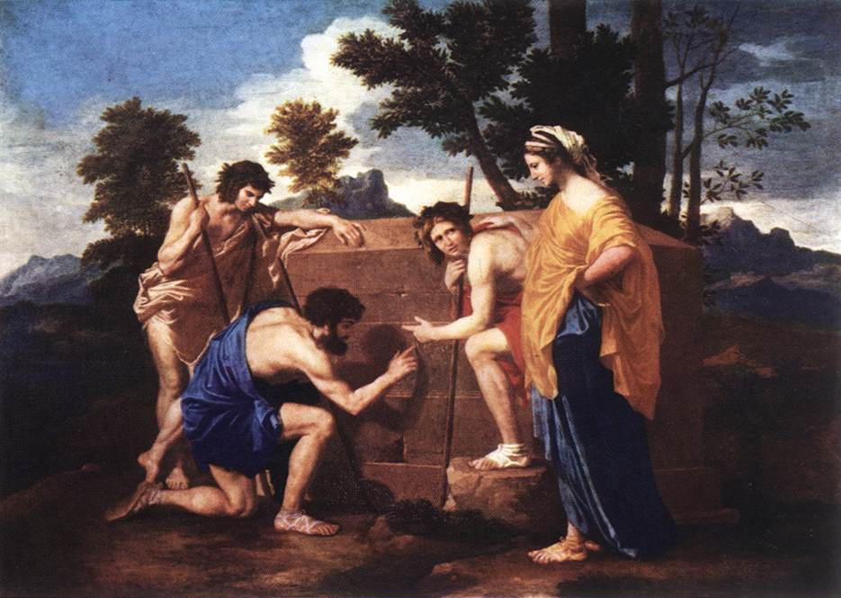

II. VISUAL EXCITEMENT WEEK 2

THE IMPACT OF THE IMAGE: motion and emotion

Video artist Bill Viola and Charles Darwin, The Expression of the Emotions in Humans and Animals

III. A RIVALRY OF THE ARTS? WEEK 2-3

- Swans and snakes: a question of beauty?
Hölderlin, Baudelaire, Yeats

- Ancient Images: Homer and Virgil; Lessing’s reading of images

SCULPTURE: The “Laocoon”-Group

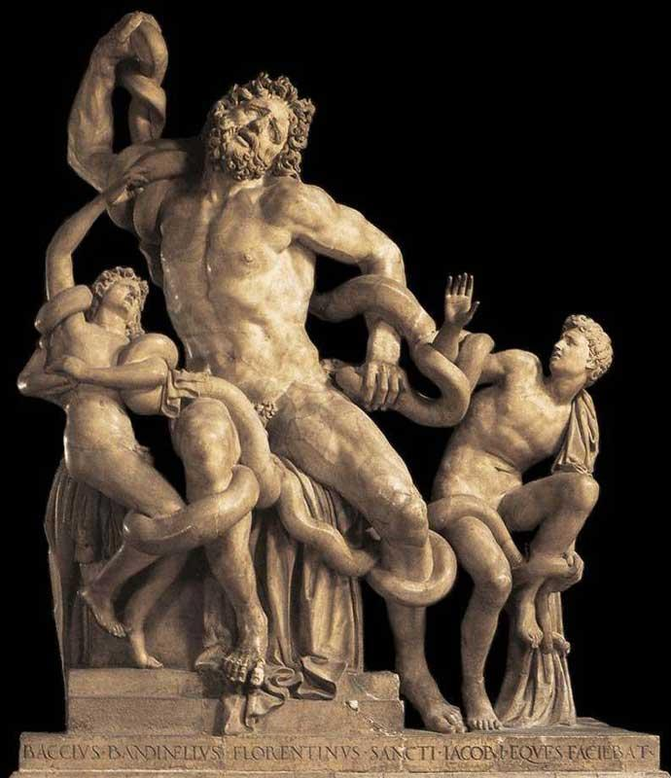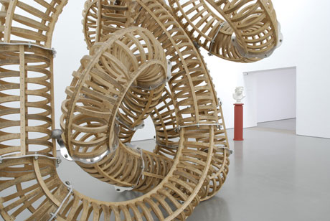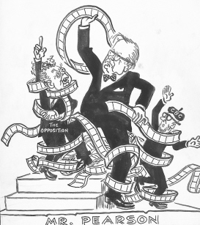

-----------------------------------------------------------------------------------------------------

LITERATURE AND IMAGERY IN THE FIRST HALF OF THE TWENTIETH CENTURY

IV. ARTIST LEGENDS WEEK 4

The modern writers: the role of the artist and the curious reader

Balzac, “The Unknown Masterpiece”
James. “The Figure in the Carpet”

PAINTING: Mabuse etc.

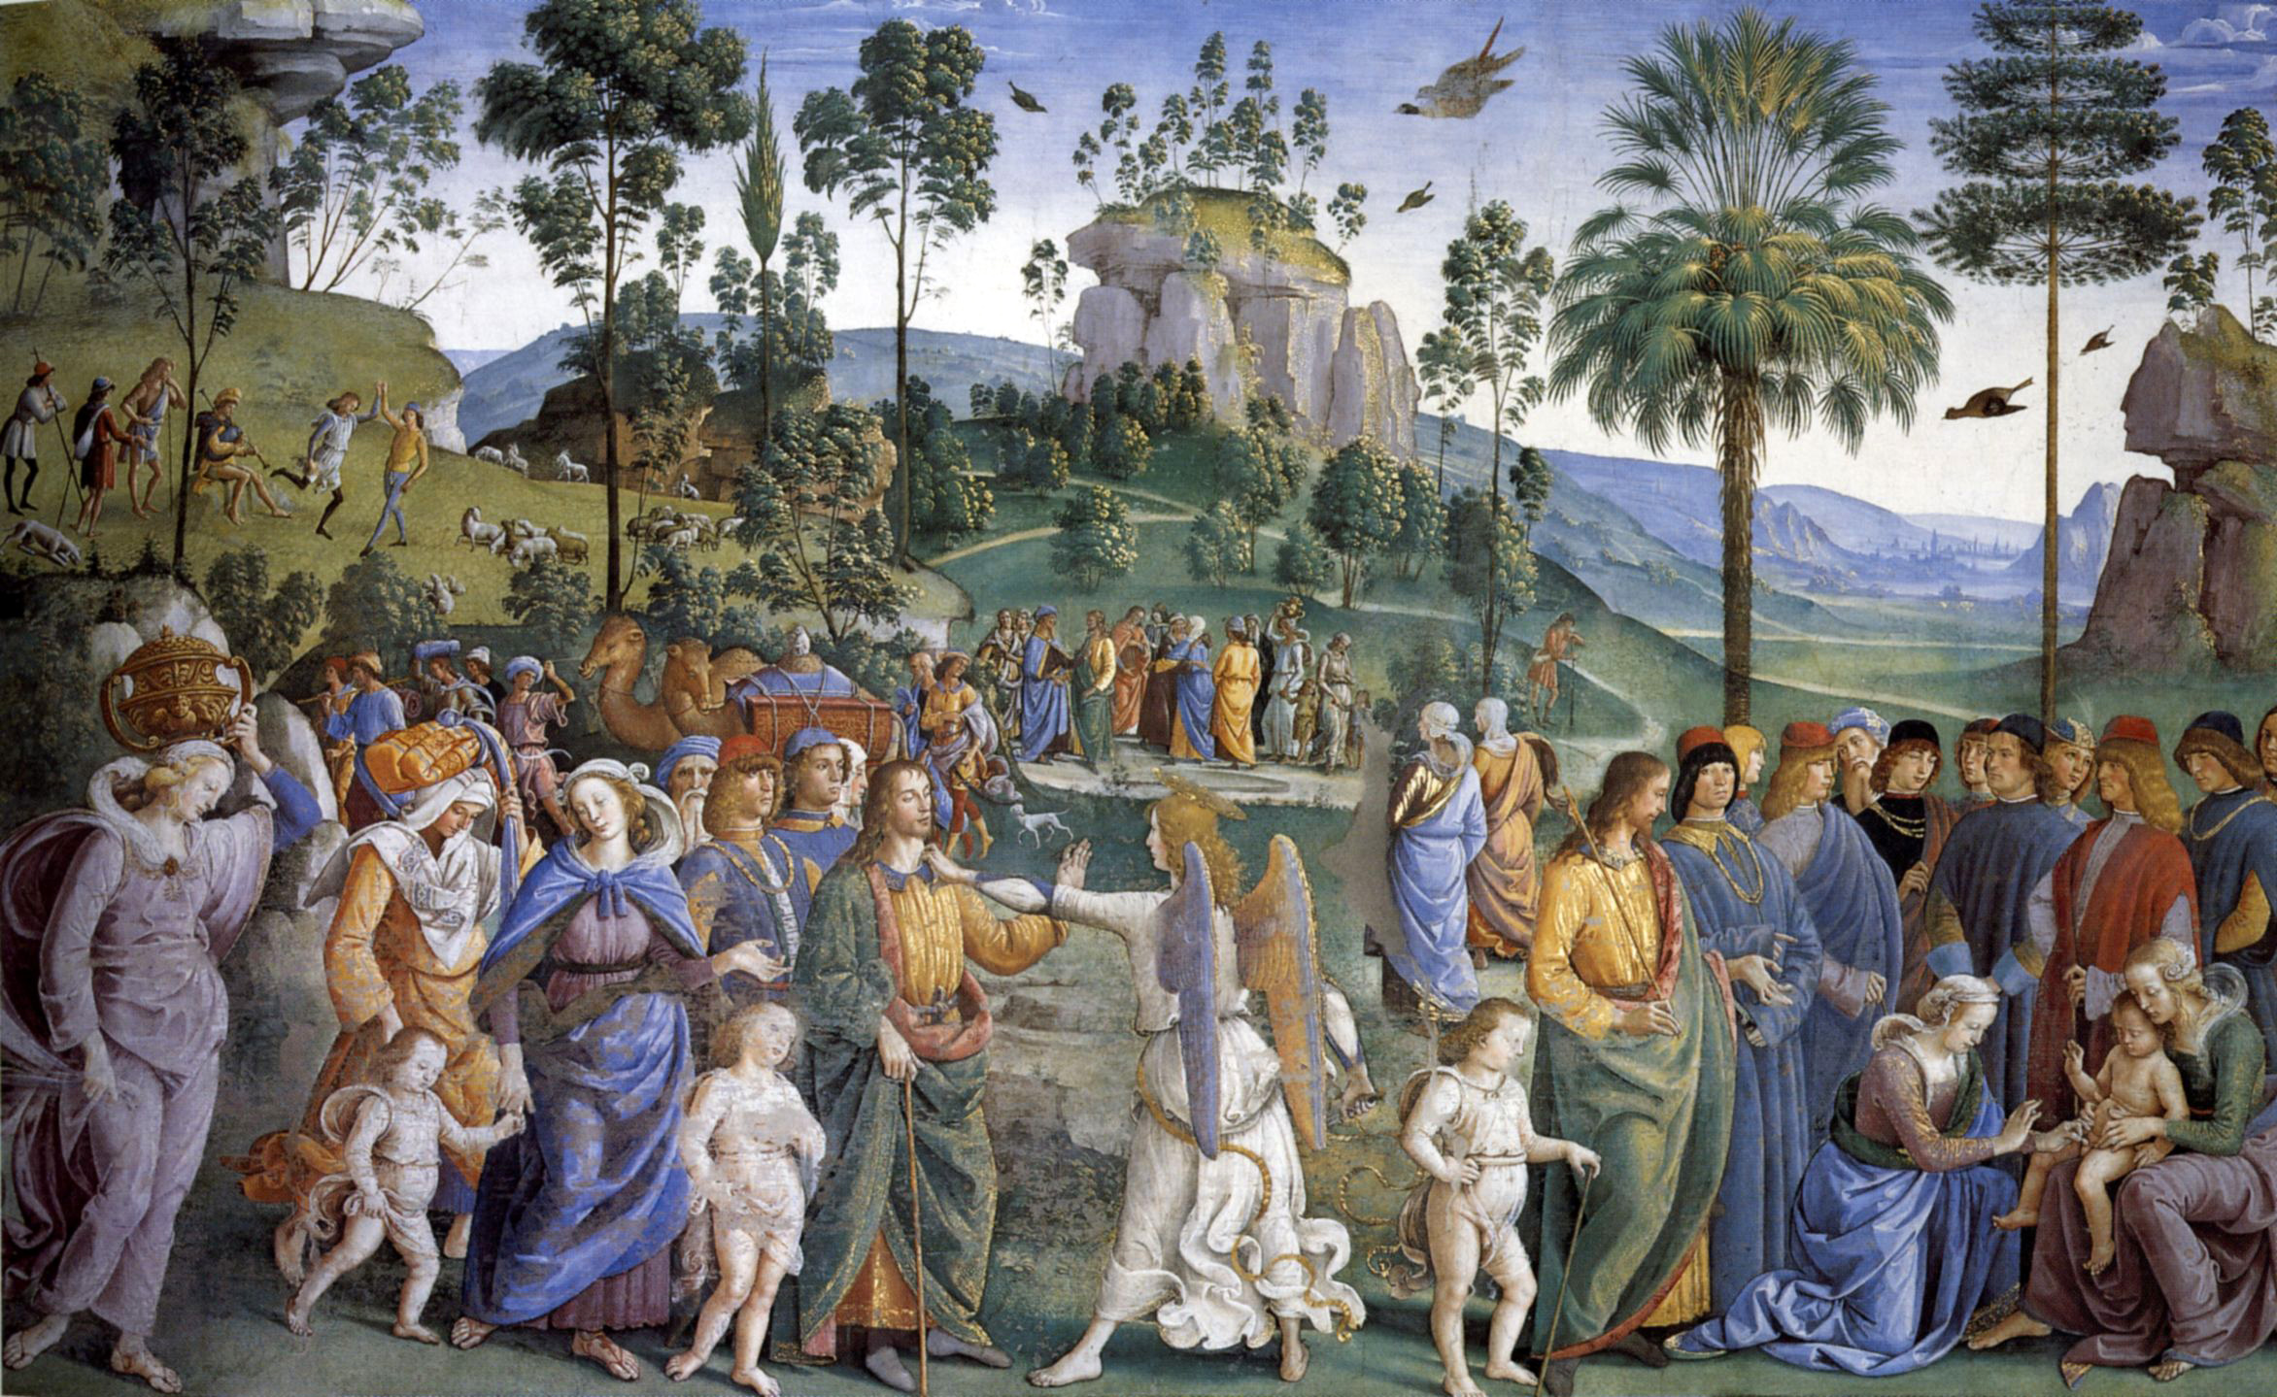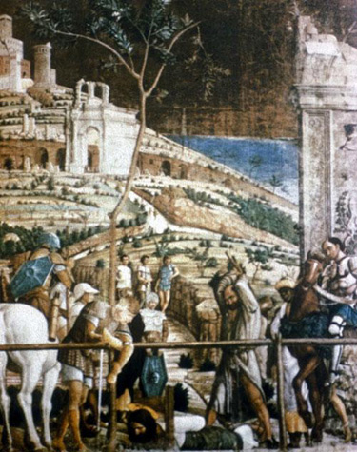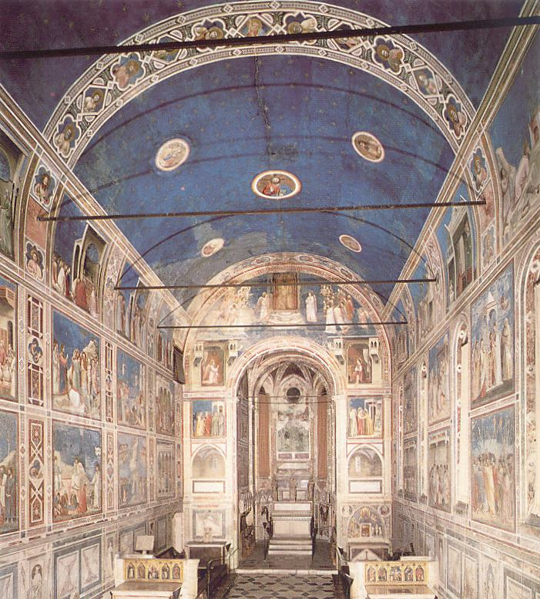

V.VISUAL MEMORIES WEEK 5
Sept 24: Essay # 1
Memory and the visual arts
Proust, Swann’s Way
PAINTING: Giotto, Botticelli, Bellini etc.

Rilke, The Notebooks of Malte Laurids Brigge
TAPESTRIES: The Lady and the Unicorn

VI. LOOKING FOR CLUES WEEK 6

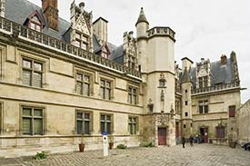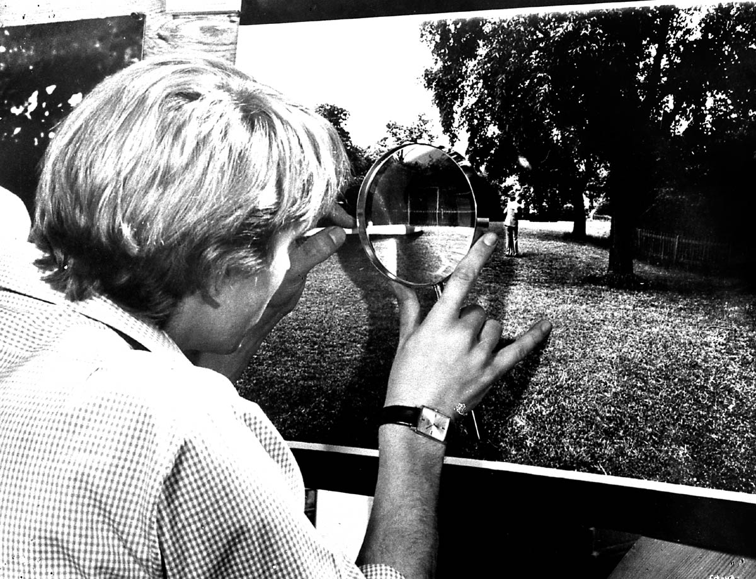

Hidden Figures: Studying postmodern prose

Cortazar, “Blow-Up”
() REF. TO PHOTOGRAPHY

WEEK 7

Woman as enigma? The Surrealists’ vision

Breton, Nadja
SURREALIST PHOTOGRAPHY: M.Ray and others

VII. MOVING IMAGES WEEK 8-9
October 22: Essay # 2

The American Avant-garde
Dos Passos, Manhattan Transfer; Eisenstein; Man Ray
() REF. TO FILM, NEWSPAPERS

The role of images in criminal investigations
Burroughs, The Last Words of Dutch Schultz
PHOTOGRAPHY: various

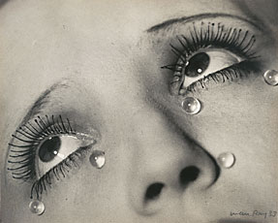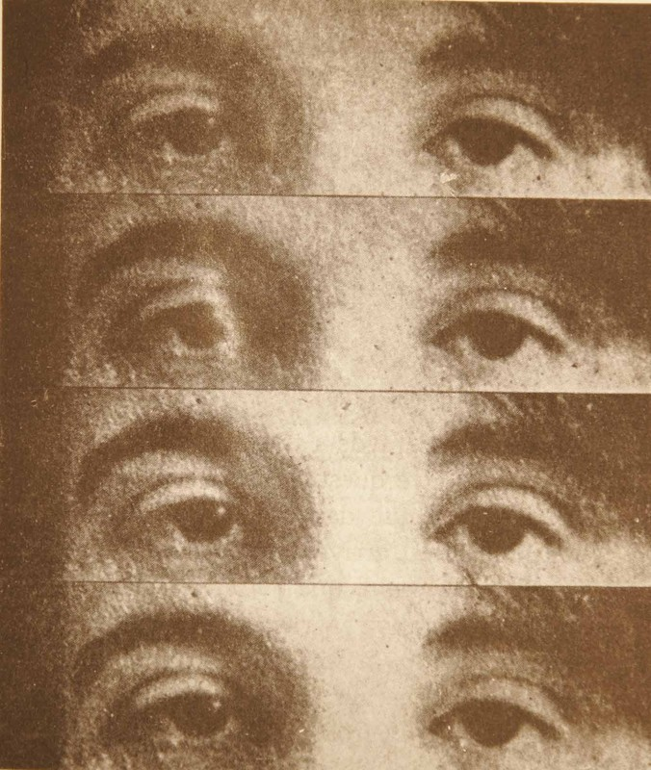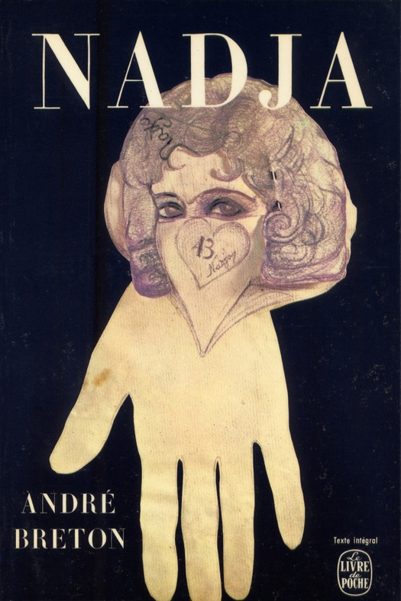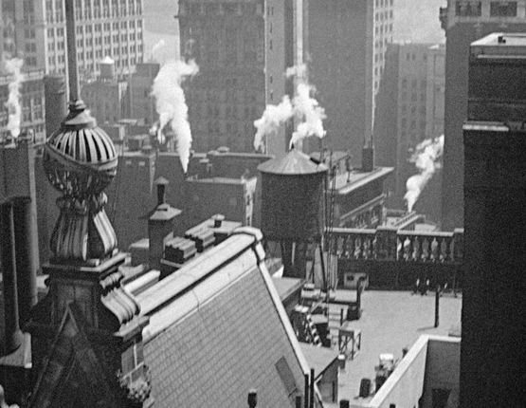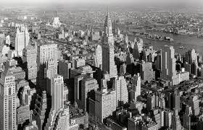

VIII. SELF-PORTRAITS WEEK 10

Portraits of the artist
Ashbery, “Self-Portrait in a Convex Mirror”
PAINTING: Parmigianino

Jean Cocteau. “Blood of a Poet;” Carroll, Through the Looking-Glass (1871), exc.
FILM, PHOTOGRAPHY, NOVEL: various

IX. UNSEEING WEEK 11-12

December 10: Essay # 3
New perspectives: Blindness in modern and postmodern texts
Maeterlinck, The Unseeing Ones

Hofmann, The Parable of the Blind

PAINTING: Brueghel; PHOTOGRAPHY: P.Strand and others

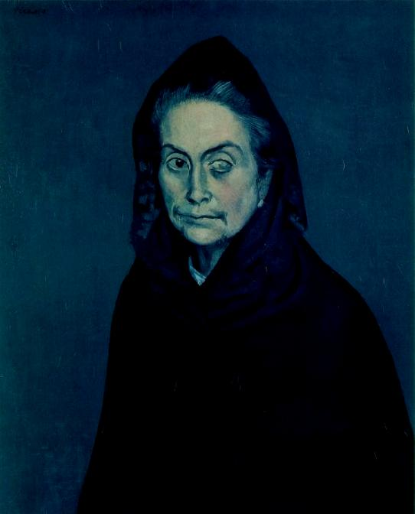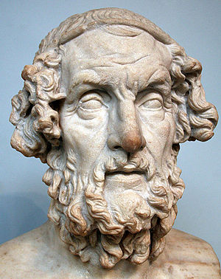

Final Examination period

