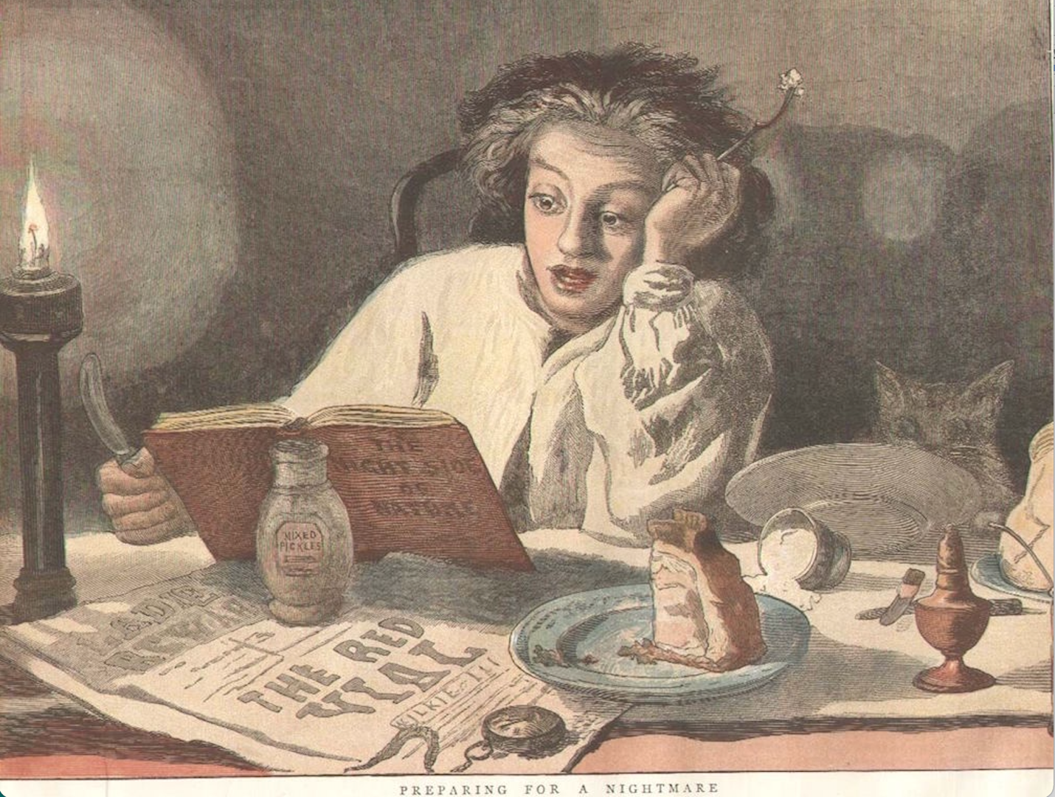

Topics in Comparative Literature: Literature and Horror
BC3143
Spring 2024
M. Cohen

Cannibals! Orphans! Strikes! Vampires!

Tremors! Tears! Disgust! Goosebumps!

All students welcome!

