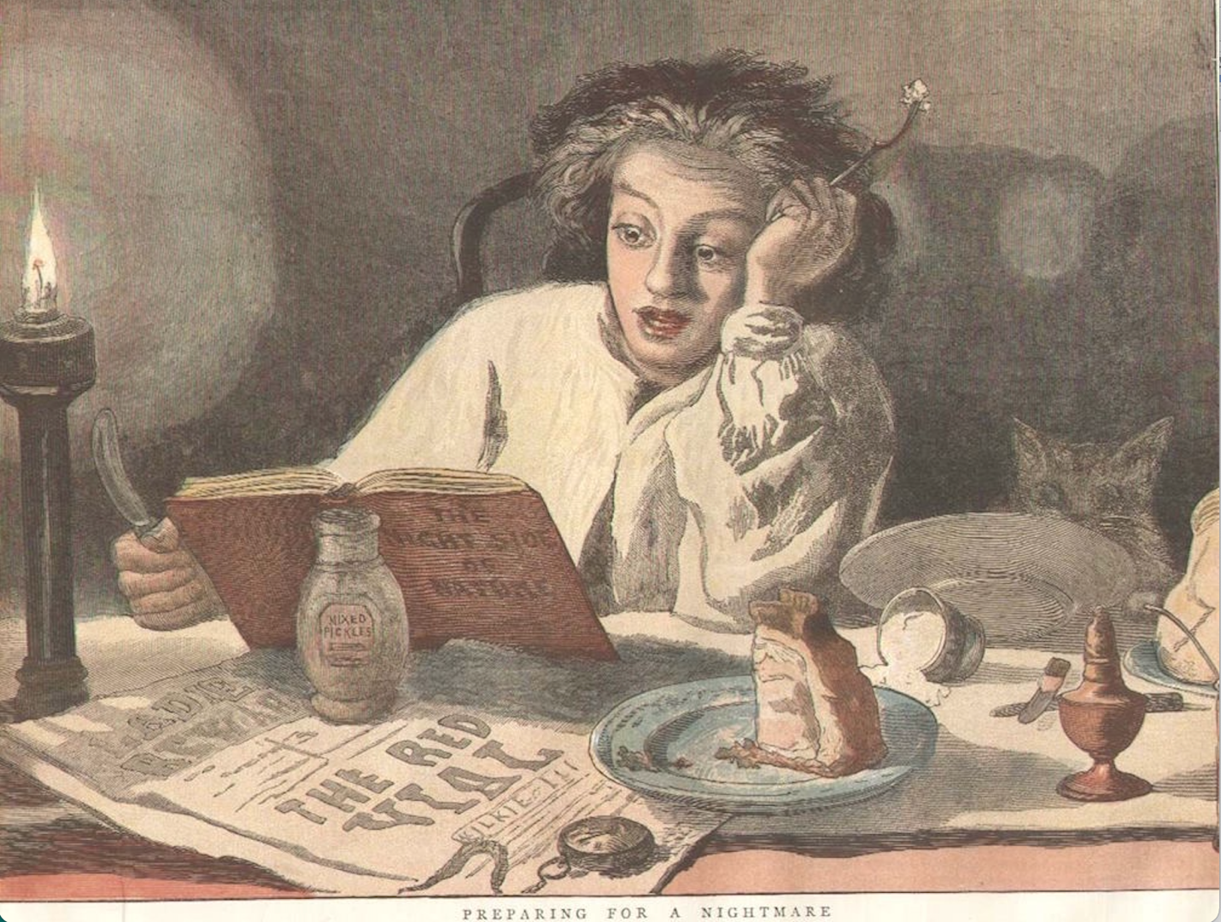

Topics in Comparative Literature: Literature and Horror
T/R 1:10-2:25
M. Cohen

Cannibals! Orphans! Strikes! Vampires!

Tremors! Tears! Disgust! Goosebumps!

All students welcome!

